1. Setting the smart home set up by using the Home devices and configuring to wireless device

Wireless devicee

In the Config of every device choose

Home Gateway as IoT server

In Advanced setting set as shown below

This is done for all devices.

Monitor devices using

IoT Monitor menu of smart phone

Rules as below

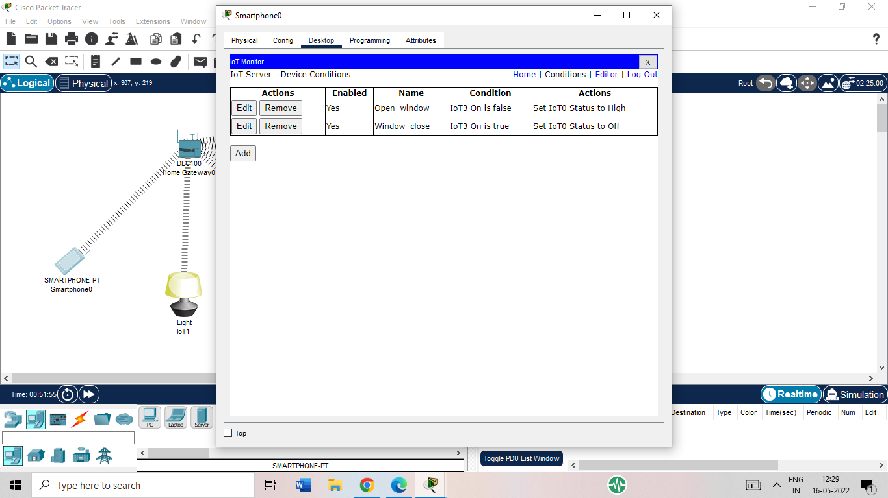

Setting Rules in IoT